Lab: Current Event Paper
Timothy Victori
Arizona State University
IFT381: Information System Security
Professor John Lewis
9/28/2025
Warlock ransomware: What you need to know
https://www.fortra.com/blog/warlock-ransomware-what-you-need-know/

. Warlock ransomware: What you need to know
https://www.fortra.com/blog/warlock-ransomware-what-you-need-know/
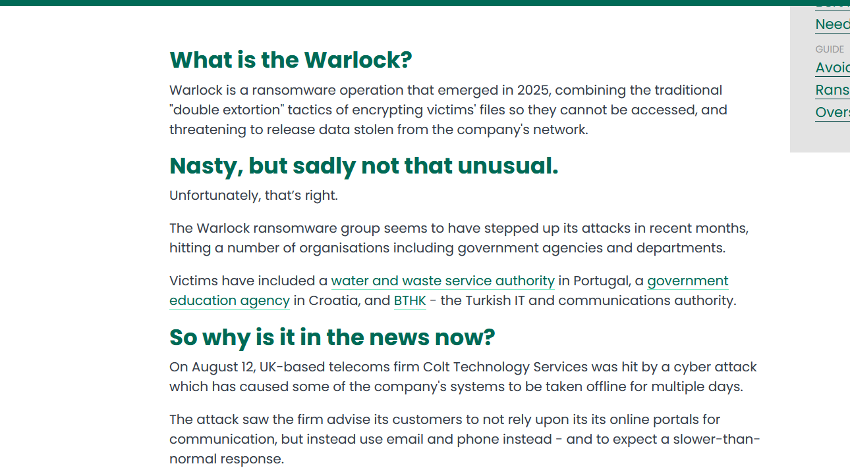
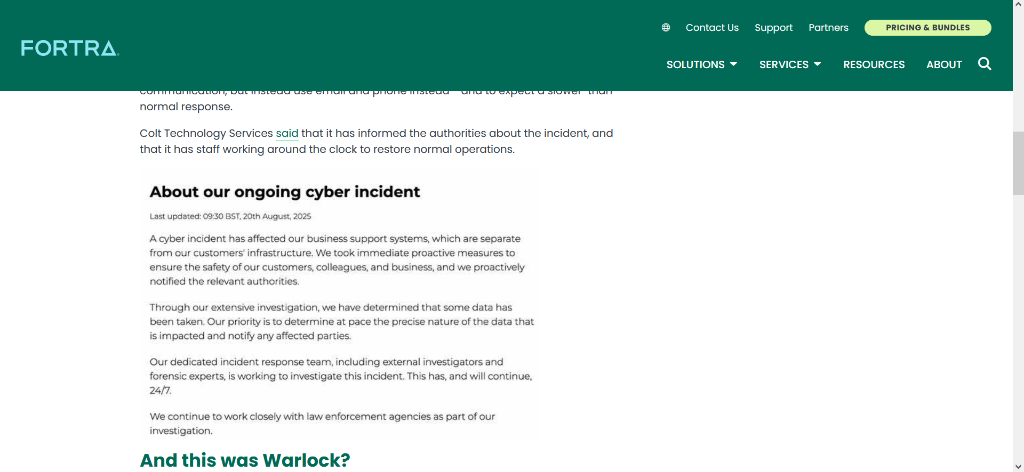
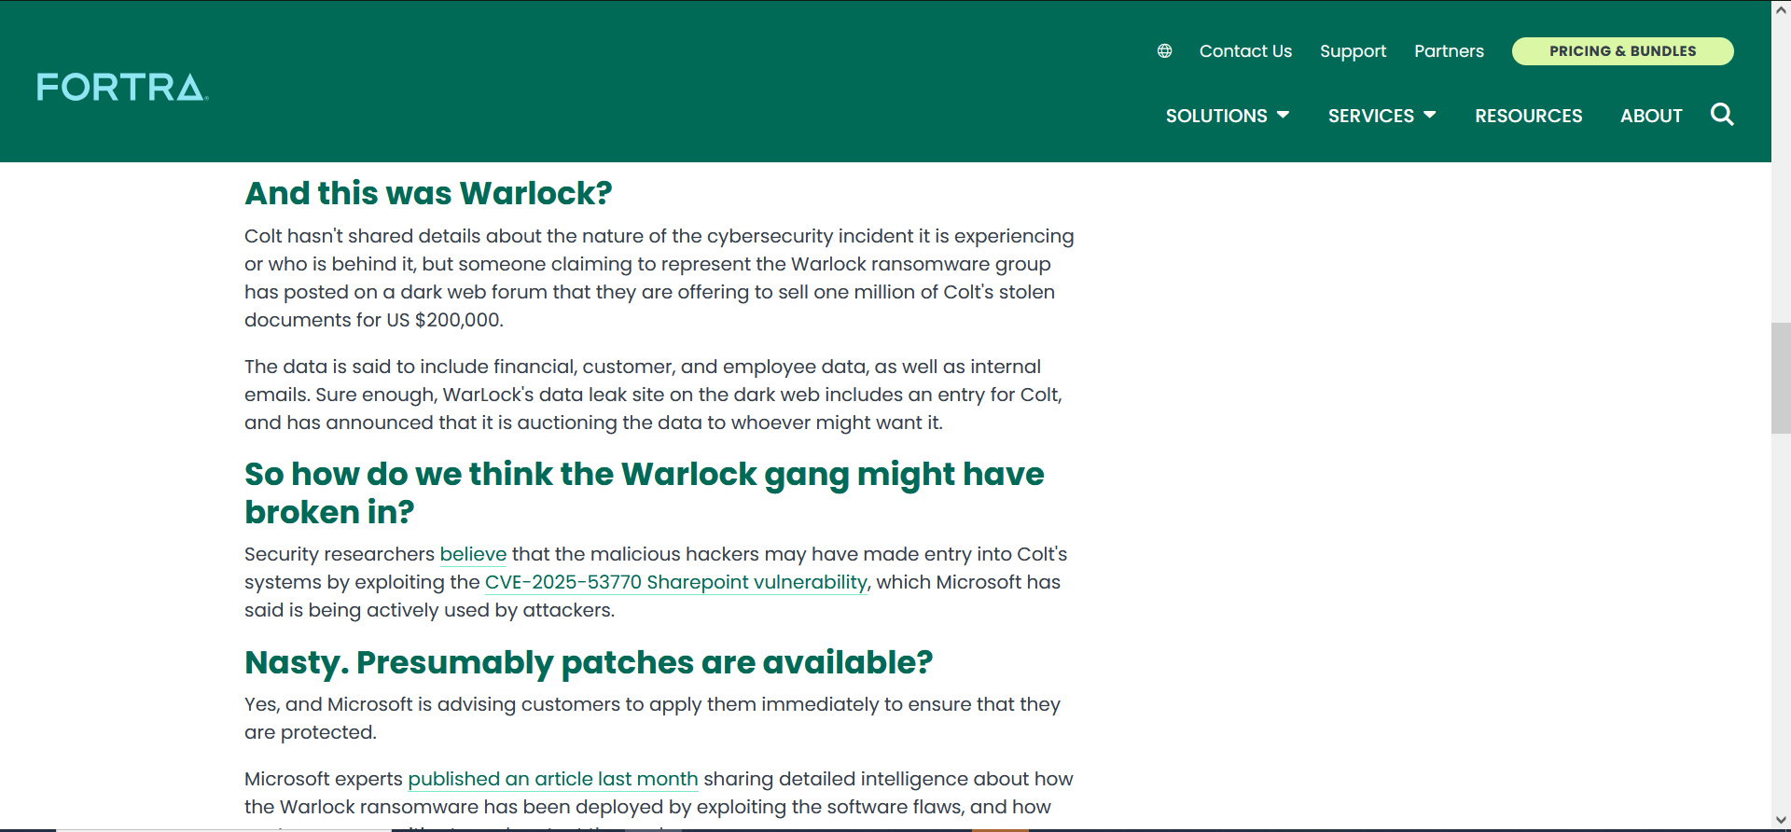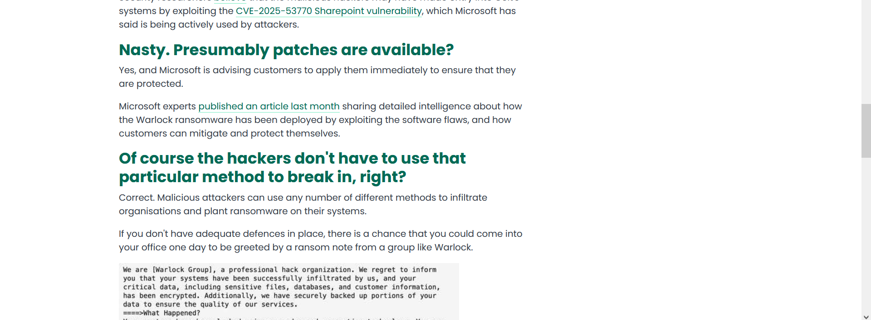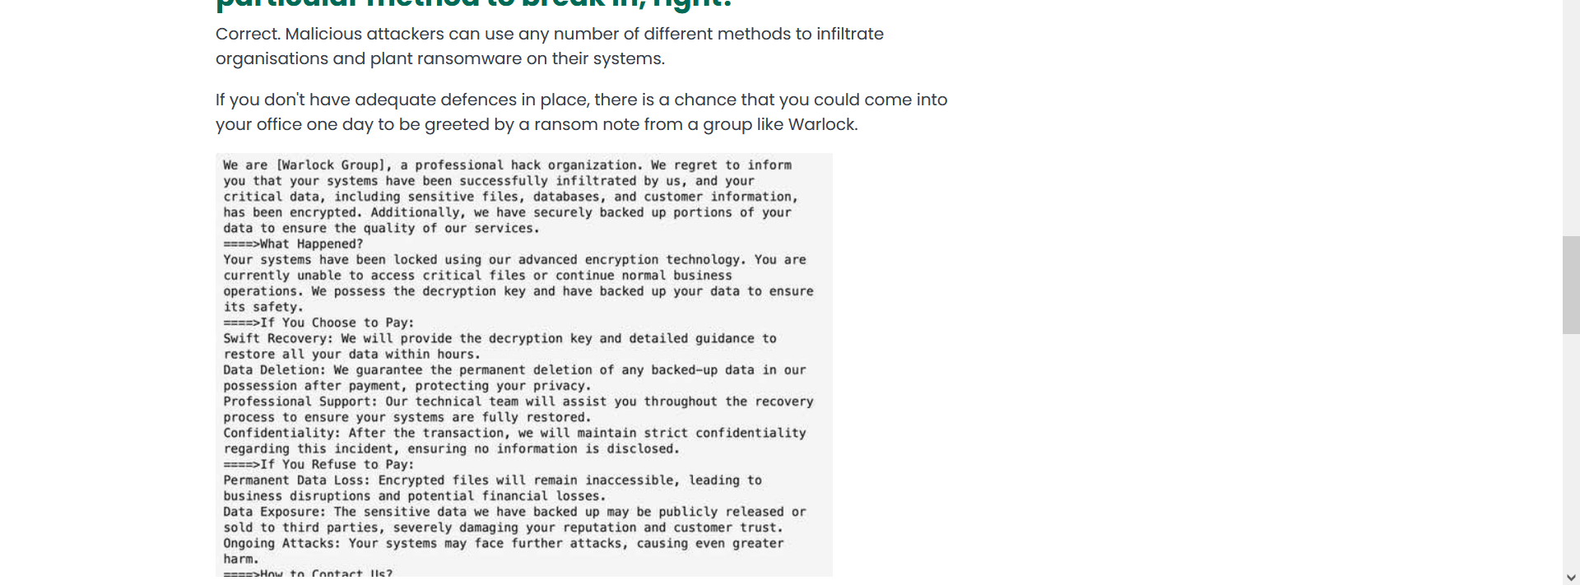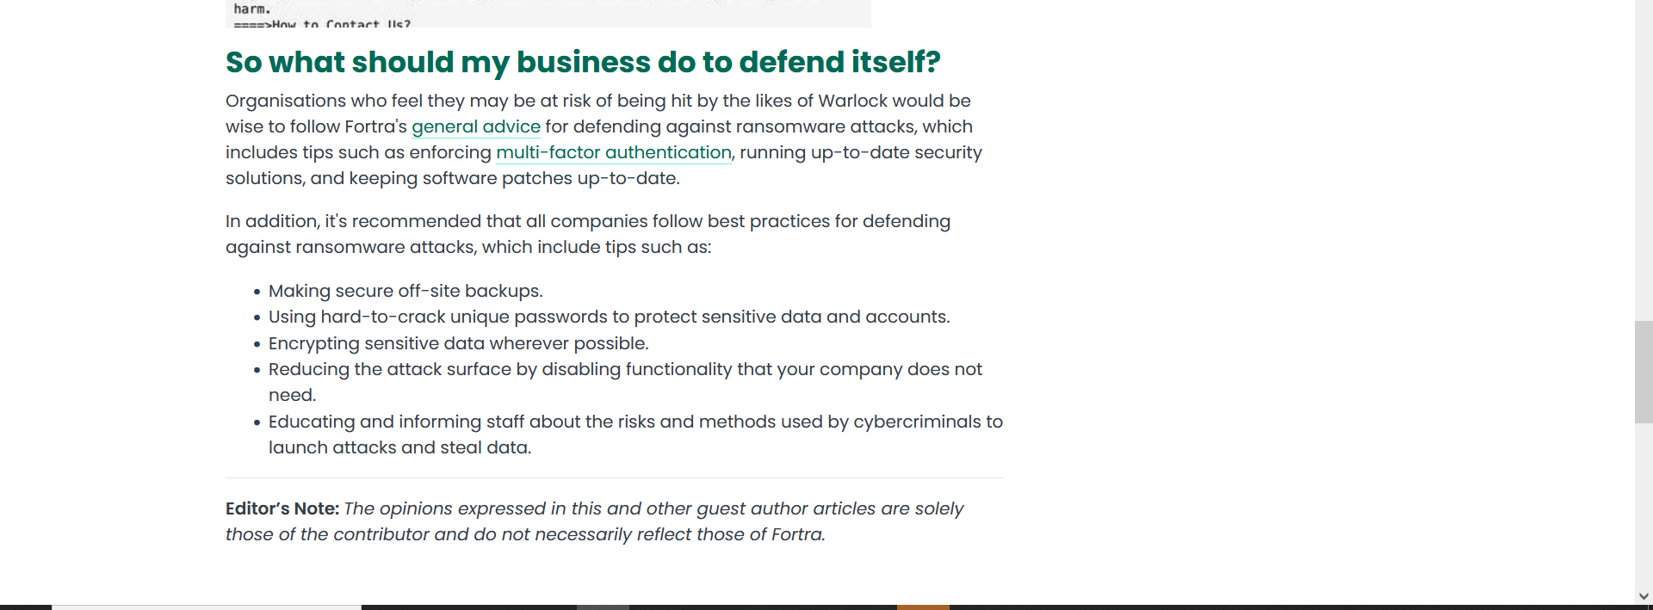
Summary:
Warlock is a ransomware that popped up this year, It uses double extortion tactics encrypting and threatening to send sensitive data to the public in order to extort a business (Forta, 2025). On August 12th Colt Technology services was hit with a cyber attack rendering their systems offline, It is theorized that CVE-2025-53770 Sharepoint vulnerability, was used. Make sure to have cyber security measures in place to prevent an attack.
Analysis:
This ransomware attack caused an issue in the CIA triad sections involving both availability and confidentiality. This particular ransomware’s “double extortion” tactic violates the availability by encrypting data to make it unusable to the user without the decryption key and the confidentiality by harvesting the data and threatening to leak it to the public. Proper training in cyber attacks as well as encrypting sensitive data when not in use will help the confidentiality part. Disabling parts of the system that are unused and having secure off-site backups can help with the availability part of the triad.
Resolution:
Microsoft is pushing out a security update to patch the vulnerability that this ransomware uses and is urging users to install the patch ASAP. General cyber security tactics such as those stated above are important in making sure a system is secure as possible.

References
Kale, V. (2015). Guide to cloud computing for business and technology managers: From distributed computing to cloudware applications, (1st ed.). Boca Raton, FL: CRC Press.
Warlock ransomware: What you need to know | fortra. (2025). https://www.fortra.com/blog/warlock-ransomware-what-you-need-know

